**3GPP TSG-RAN WG4 Meeting #114bis *R4-2503659***

**Wuhan, Hubei, China, 07th – 11nd April, 2025**

**Agenda item:** 7.16.2

**Source:** Samsung

**Title:** Simulation results on spatial channel model

**Document for:** Discussion

# Introduction

In the RAN#104 meeting, the SID [1] for “New SID: Study on spatial channel model for demodulation performance requirements” has been approved, which starts from RAN4#112 in Aug 2024 and targeting to complete by RAN#109 in Sep 2025 [2]. The objectives are as below:

|  |
| --- |
| * Study practical spatial channel modelling methodology for both SU- and MU-MIMO demodulation requirements and CSI reporting requirements:   + Identify the limitations of the current (i.e. up to and including Release 18) channel models and corresponding scenarios and how they relate to UE MIMO performance   + Consider both Clustered Delay Line (CDL)-based and TDL-based channel modelling approaches     - For CDL-based channel modelling, use the tuned repeatable spatial channel model of TR38.827 as the starting point and identify any necessary changes.   + Study and verify test methodology feasibility including test complexity and achievable results uncertainty. The test complexity shall not be significantly increased.   + The methodology shall include both FR1 (conducted) and FR2 (wireless cable), with first priority for FR1. |

In RAN4#113 and RAN4#114 meetings, parameter assumptions, CDL methodologies and AAV configurations has been agreed for simulations [3][4].

In this contribution, we share our simulation results for CDL-based model, TDL extended model and baseline TDL channel model.

# Simulation assumptions

## Agreed simualtion assumptions

For CDL based channel modeling, we combine the simulation assumptions argeed in RAN4#113 meeting [3] and RAN4#114 meeting [4] as below.

|  |  |  |  |  |  |
| --- | --- | --- | --- | --- | --- |
| **Parameter** | | **SU-MIMO PDSCH (FR1)** | **SU-MIMO PMI (FR1)** | | **MU-MIMO PDSCH (FR1)** |
| Bandwidth | | 40MHz | | | |
| Subcarrier spacing | | 30kHz | | | |
| Duplex mode | | TDD | | | |
| TDD Slot Configuration Pattern | | 7DS2U | | | |
| FR / Carrier frequency | | FR1 / 3.5 GHz | | | |
| UE receiver type | | IRC Baseline | IRC Baseline | | IRC, E-IRC |
| Number of Tx Ports | | 8,4 | 8 | | 4 |
| Number of Rx Ports/Antennas | | 8,4 | 4 | | 4 |
| Number of layers | | 8,4 | 4,2 | | 2+2 |
| PMI | | Random, FFS Fixed | Follow, Random | | UE1: Random  UE2: Random and not equal to UE1,  Orthogonal |
| Waveform | | CP-OFDM with normal CP | | | |
| Channel Bandwidth/SCS | | 40MHz/30kHz | | | |
| MCS | | 13 (64 QAM table) | | | |
| PDSCH configuration | Mapping type | Type A | | | |
| k0 | 0 | | | |
| Starting symbol (S) | 2 | | | |
| Length (L) | 12 | | | |
| PDSCH aggregation factor | 1 | | | |
| Resource allocation type | Type 0 | | | |
| VRB-to-PRB mapping type | Non-interleaved | | | |
| VRB-to-PRB mapping interleaver bundle size | N/A | | | |
| PDSCH DMRS configuration | DMRS Type | Type 1 | | | |
| Number of additional DMRS | 1 | | | |
| Maximum number of OFDM symbols for DL front loaded DMRS | 2 (for rank > 4)  1 (for rank <= 4) | | | |
| Codebook configuration | CodebookType | type-I-SP | type-I-SP, eType-II | | type-I-SP |
| Codebook configuration | For 8Tx  (N1,N2,O1,O2) = (4,1,4,1)  For 4Tx  (N1,N2,O1,O2) = (2,1,4,1) | For typeI-SP:  (N1,N2,O1,O2) = (4,1,4,1)  For eType-II:  (N1,N2,O1,O2) = (4,1,4,1)  [ paramCombination-r16=6 (L=4, pν=1/2, 1/4, β=1/2) ] | | (N1,N2,O1,O2) = (2,1,4,1) |
| PDSCH DMRS Precoding Configuration | | For Random precoding: for every PRB Bundle (size=2)  For Fixed precoding: Wideband PMI | For typeI-SP (random and follow): Wideband PMI  For eType-II with follow and random: TBD | | For Random precoding: for every PRB Bundle (size=2) |
| NZP CSI-RS for CSI acquisition | CSI-RS resource Type | Periodic | | | |
| Number of CSI-RS ports (X) | 4 CSI-RS Ports (2,1) for 4 Layer  8 CSI-RS Ports (4,1) for 8 Layer | 8 CSI-RS Ports (4,1)  4 CSI-RS Ports (2,1) | | TBD |
| Density (ρ) | 1 | | | |
| First OFDM symbol in the PRB used for CSI-RS (l0) | (5) | | | |
| CQI/RI/PMI delay | | N/A | 7 ms | N/A | |
| Number of HARQ Processes | | 8 | | | |
| Maximum HARQ transmissions | | 4 | | | |
| Channel Models | | The purpose of the study item. | | | |
| Testing Metric | | Full Throughput Curves | | | |
| Channel Geometry (CDL) | LCS UE | α = 180°, β=0°, γ = 0° | | | |
| LCS gNodeB | α = 0°, β=10°, γ = 0° | | | |
| GCS UE | Height = 1.5 m; Azimuth = 0; X Coordinate = 100 m | | | |
| GCS gNodeB | Height = 25 m; Azimuth = 0; X Coordinate = 0 m | | | |
| BS Antenna Polarisation | (+45, -45) | | | |
| BS Radiation Pattern | defined in TR38.901 Table 7.3-1. | | | |
| UE Antenna Polarisation | (0, 90) | | | |
| UE Antenna Radiation Pattern | Omnidirectional | | | |
| Antenna Panel Placement | YZ Plane | | | |

## Other parameters and configurations

**Channel Model Configurations**

For the channel model configurations, we use option A1, TDL extended model option B1 and baseline TDLC300 as below.

* Option A1: CDL (TR 38.753) with Table 7.2.1-8 in TR 38.827
* Option B1: TDL extended model
* Baseline: TDLC300 defined in TS38.101-4

**AAV Configurations**

For AAV configurations of CDL based channel modeling, below options are used for initial simulation

* Option 1Y: with Antenna Array Virtualisation (AAV) using subarray configuration
  + (M,N,P,Ms,Ns) = (8,2,2,8,1) for 4Tx CSI-RS Ports (option Y)
* Option 3: with AAV with the following configuration:
  + (M,N,P,Ms,Ns) = (1,2,2,1,1) for 4Tx CSI-RS Ports

**Doppler frequencies**

* 10Hz
* 100Hz

**Correlation matrix for baseline TDLC cases**

* ULA Low
* X-Pol Medium
* X-Pol High
* ULA Medium

**Extended TDL parameters**

* Two clusters for rank4 with power [0, -3] dB, angles [0, $π/2$**]**
* Four clusters for rank8 with power [0, 0, -3, -3] dB, angles [0, $π/6,$ $π/2,$ $3π/2$]

# Simulation results

## PDSCH demodulation performance for 4Tx4Rx4layer Doppler 10Hz configuration

**Legacy TDL and 38.827 based CDL comparison**

Firstly, 38.827 based CDL is the starting point, hence it is important to compare the simulation results between legacy TDL channel models and 38.827 based CDL channel model in Figure 3-1. For legacy TDL, three correlation matrixes are deployed including Low, XP Medium, XP High. For 38.827 based CDL, AAV model option 3 and option 1Y are simulated.

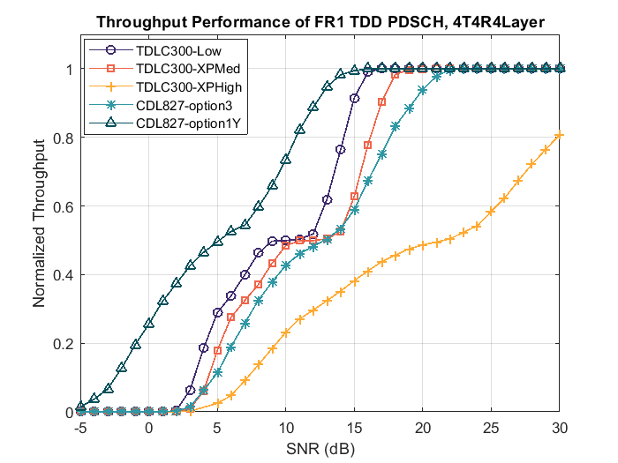

Figure 3-1 PDSCH demodulation performance comparison between legacy TDL and 38.827 based CDL

From Figure 3-1, we have below observations:

* Peak throughput is hard to reach for legacy TDLC300-10 with XP High correlation matrix.
* 38.827 based CDL option 1Y has higher performance than option 3 because of the beamforming gain.

Hence, we need analysis the 38.827 based CDL results with SNR normalization factor as Figure 3-2, in which the SNR normalization factor obtained from simulation results as Table 3-1.

Table 3-1 SNR normalization factor for 4Tx4Rx 38.827 based CDL

|  |  |  |  |
| --- | --- | --- | --- |
| Number of antennas | Models | Normalization factor (linear) | Normalization factor (dB) |
| 4Tx4Rx | CDL827-option3 | 0.829431407 | -0.812195238 |
| CDL827-option1Y | 4.385069685 | 6.419764993 |
| 8Tx8Rx | CDL827-option3 | 0.890083597 | -0.505692023 |
| CDL827-option1Y | 4.384104304 | 6.418808781 |

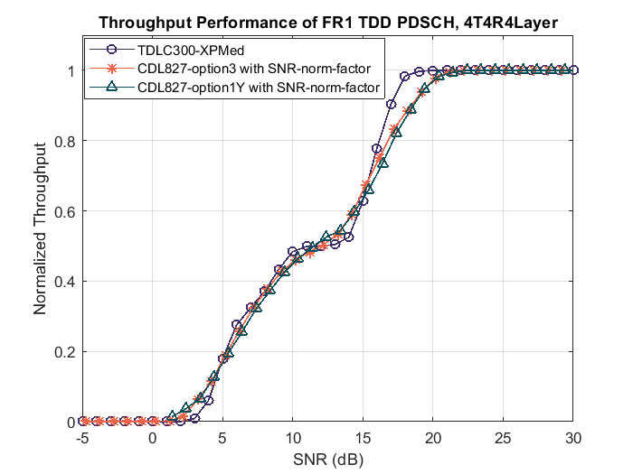

Figure 3-2 PDSCH demodulation performance comparison with SNR normalization factors

From Figure 3-2, we have below observations:

* 38.827 based CDL option 3 and option 1Y have almost the same PDSCH demodulation performance when SNR normalization factors are considered.
* 38.827 based CDL options have similar PDSCH demodulation performance as legacy TDL300-10 XP Medium configuration.

**38.827 based CDL and 38.901 based CDL comparison**

According our discussion t-docs, the only difference between 38.827 based CDL and 38.901 based CDL is the AoA/AoD/ZoA/ZoD angles. the PDSCH demodulation performance curves are close as Figure 3-3 shows, and the SNR working points at 70% @ maximum TP are almost the same.

Note: results for 38.901 based CDL option 1Y need to be update later.

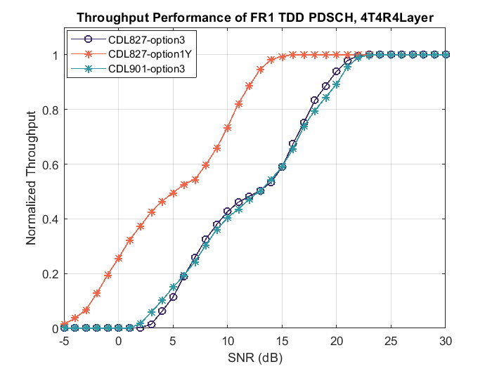

Figure 3-3 PDSCH demodulation performance comparison between 38.827 based CDL and 38.901 based CDL

**Legacy TDL and extended TDL comparison**

The simulation results for PDSCH demodulation performance comparison between legacy TDL and extended TDL models as Figure 3-4. From Figure 3-4, we have below observations:

* Extended TDL with XP high correlation could reach peak throughput.
* Extended TDL has better performance than legacy TDL cases.
* Extended TDL with XP high correlation has better performance than low correlation.

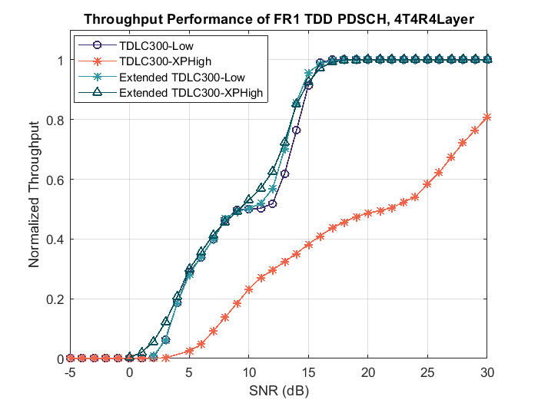

Figure 3-4 PDSCH demodulation performance comparison between legacy TDL and extended TDL

## PDSCH demodulation performance for 8Tx8Rx8layer Doppler 10Hz configuration

**Legacy TDL and 38.827 based CDL comparison**

For 8Tx8Rx8Layer in Figure 3-5, we compare the PDSCH demodulation performance between legacy TDLC300-10 with low/XP Medium correlation matrixes and 38.827 based CDL option 3/option 1Y. from this comparison, the observations could be summarized as below

* For legacy TDL, the PDSCH demodulation performance of both codewords are almost the same.
* For 38.827 based CDL, the PDSCH demodulation performance of both codewords have some difference, especially for option 1Y.
* TDLC300-10 with XP Medium correlation matrix could not reach peak throughput.

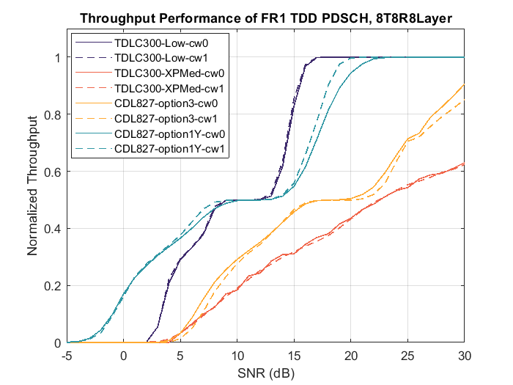

Figure 3-5 PDSCH demodulation performance comparison between legacy TDL and 38.827 based CDL

## PMI reporting performance for 8Tx4Rx2layer Doppler 10Hz configuration

**Legacy TDL and 38.827 based CDL comparison**

For 8Tx4Rx2Layer results in Figure 3-6, the PMI reporting performance are compared between legacy TDL and 38.827 based CDL models, for single panel Type I codebook and eType II codebook. The Gamma values are summarized as Table 3-2.

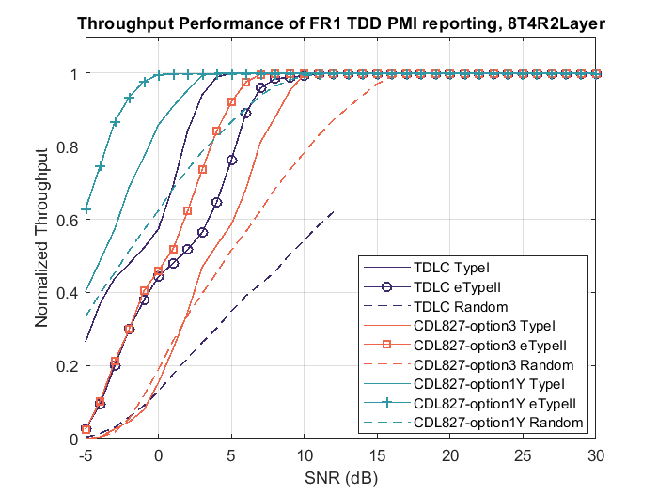

Figure 3-6 PMI reporting performance comparison between legacy TDL and 38.827 based CDL

Table 3-2 Gamma values for PMI reporting performance

|  |  |  |  |
| --- | --- | --- | --- |
| Number of antennas | Models | SNR @ 90% maximum TP (dB) | Gamma |
| 8Tx4Rx2Layer | TDLC TypeI | 4.6 | 2.73 |
| TDLC eTypeII | 8.1 | 1.97 |
| CDL827 option3 TypeI | 8.3 | 1.31 |
| CDL827 option3 eTypeII | 4.7 | 1.86 |
| CDL827 option1Y TypeI | 0.8 | 1.34 |
| CDL827 option1Y eTypeII | -2.5 | 1.88 |

From Figure 3-6 and Table 3-2, the observations could be summarized as below

* For legacy TDL300-10 with XP High correlation, the performance of eType II codebook is even worse than Type I codebook.
* For 38.827 based CDL, the performance of eType II codebook is between than Type I codebook.
* The Gamma values of 38.827 based CDL are less than legacy TDL as the performance of random PMI case has better performance.

**PMI reporting performance of extended TDL**

The PMI reporting performance of extended TDL model with XP High correlation is as Figure 3-7, and the Gamma values as Table 3-3. From Figure 3-7 and Table 3-3, the observations could be summarized as below

* For extended TDL300-10 with XP High correlation, the performance of eType II codebook is better than Type I codebook.
* The Gamma values of extended TDL300-10 model are larger than 38.827 based CDL since the performance of random PMI case has worse performance.

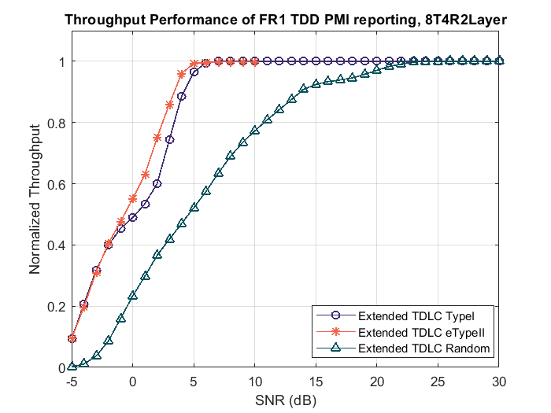

Figure 3-7 PMI reporting performance of extended TDL model

Table 3-3 Gamma values for PMI reporting performance of extended TDL model

|  |  |  |  |
| --- | --- | --- | --- |
| Number of antennas | Models | SNR @ 90% maximum TP (dB) | Gamma |
| 8Tx4Rx2Layer | Extended TDL TypeI | 4.2 | 1.87 |
| Extended TDL eTypeII | 2.4 | 2.33 |

## PMI reporting performance for 8Tx4Rx4layer Doppler 10Hz configuration

For 8Tx4Rx4Layer results in Figure 3-8, the PMI reporting performance are compared between legacy TDL and 38.827 based CDL models, for single panel Type I codebook and eType II codebook. The Gamma values are summarized as Table 3-4.

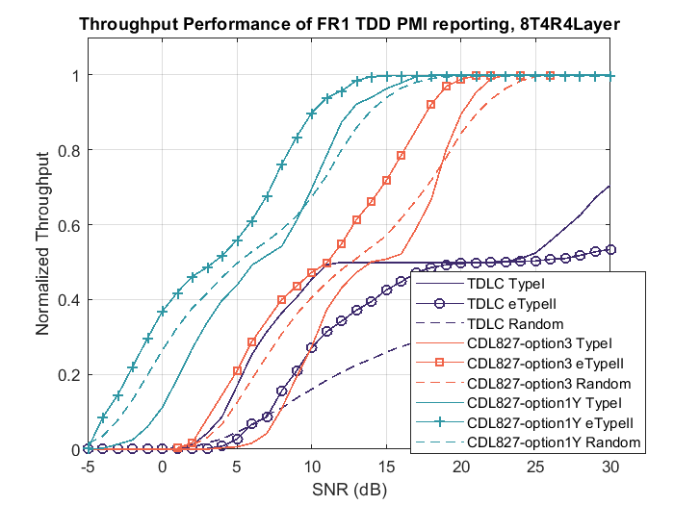

Figure 3-8 PMI reporting performance comparison between legacy TDL and 38.827 based CDL

Table 3-4 Gamma values for PMI reporting performance

|  |  |  |  |
| --- | --- | --- | --- |
| Number of antennas | Models | SNR @ 90% maximum TP (dB) | Gamma |
| 8Tx4Rx4Layer | TDLC TypeI | NA | NA |
| TDLC eTypeII | NA | NA |
| CDL827 option3 TypeI | 20.1 | 1.07 |
| CDL827 option3 eTypeII | 17.6 | 1.30 |
| CDL827 option1Y TypeI | 12.5 | 1.08 |
| CDL827 option1Y eTypeII | 10.1 | 1.32 |

From Figure 3-8 and Table 3-4, the observations could be summarized as below

* For legacy TDL300-10 with XP High correlation, the performance of eType II codebook is even worse than Type I codebook.
* For 38.827 based CDL, the performance of eType II codebook is between than Type I codebook.
* For 38.827 based CDL, the performance of Type I codebook is worse than random PMI case at lower SNR range.
* The Gamma values of 38.827 based CDL are small as the performance of random PMI case has better performance than legacy TDL cases.

# Reference

[1] RP-241610, New SID: Study on spatial channel model for demodulation performance requirements, RAN#104 meeting, Nokia, BT Plc, AT&T, Bell Mobility, Bouygues Telecom, China Telecom, CMCC, Deutsche Telekom, Ericsson, Intel Corporation, KDDI, Keysight, KT Corp., MediaTek, NTT Docomo, Orange, Qualcomm, Rohde & Schwarz, Samsung, SK Telecom, Spark NZ, Telecom Italia, Telefonica, Telenor, Telia Company, Telstra, T-Mobile USA, Verizon, Vodafone, ZTE Corporation

[2] RP-250577, Revised SID: Study on spatial channel model for demodulation performance requirements, RAN#107 meeting, Nokia, BT Plc

[3] R4-2419782, Way Forward for [113][320]NR_SCM, RAN4#113 meeting, Nokia

[4] R4-2502378, Way Forward for [114][322]NR_SCM, RAN4#114 meeting, Nokia